

**Final Project**

Submitted by:

NOLAN F. SUNICO

Table of Contents

I INTRODUCTION 4

II OBJECTIVES 5

**Features** 5

**Admin Role:** 5

**User Role:** 5

**System Architecture** 5

**Installation** 6

➢ **Requirements:** 6

**Usage** 6

**Admin Panel** 6

**Manage Tickets** 6

**Update Catalog** 7

**Categories** 7

**Category Groups:** 7

**Offices:** 7

**Office Types:** 7

**Manage Users and Roles** 7

**Manage Users** 7

**Manage Roles** 7

**User Panel** 7

**Create a Ticket** 7

**Submit a Ticket** 7

**View a Ticket** 7

**View own Ticket** 7

**Security Considerations** 7

**Support and Troubleshooting** 8

III PROGRAM SCREEN SHOTS 9

Visitor’s Welcome Page: 9

Login Page: 9

Registration Page: 10

Main Dashboard: 10

Support Ticket Management Page: 11

Action Ticket Dialog Box: 12

Add New Ticket Dialog Box: 12

Categories Page: 13

Category Group page: 13

Office Management Page: 14

User Management Page: 14

Update User Dialog Box: 15

Roles and Permissions Management Page: 15

IV SOURCE CODE 16

V SUMMARY AND DISCUSSION 16

# I INTRODUCTION

The eTicketing System stands as a robust web-based application meticulously crafted using CodeIgniter 4.4, with a MySQL Database serving as its dynamic backend. This purpose-built system is ingeniously designed to simplify and enhance the management of support tickets. Tailored to address the diverse needs of both administrators and regular users, it delivers an all-encompassing platform for the seamless creation, administration, and resolution of support tickets.

One of its key features lies in its sophisticated Role-Based Account Controls, which effectively manage permissions and role assignments. This functionality is executed through the powerful routing facilities and authorization mechanisms provided by CodeIgniter 4.4. Registration for users is a straightforward process, automatically assigning the default role of "User" for non-administrative accounts.

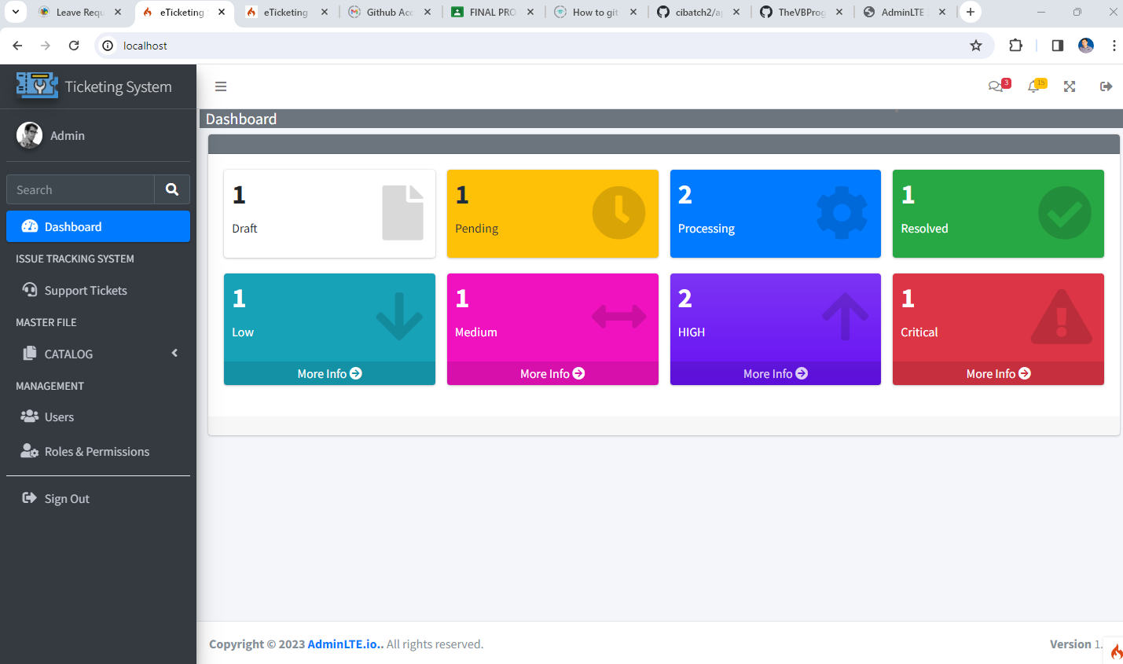Additionally, the eTicketing System boasts a visually appealing interface with the integration of the Admin LTE 3.2.0 template and the latest Bootstrap 4.0 cascading stylesheet. This not only ensures a modern and user-friendly experience but also provides administrators with a comprehensive dashboard. Through this dashboard, they can effortlessly monitor the status and severity levels of the support tickets submitted, allowing for efficient tracking and resolution.

# II OBJECTIVES

## **Features**

### **Admin Role:**

#### Ticket Management:

* Create, view, update, and resolve support tickets.
* Categorize tickets based on various aspects, such as IT, Facilities Management, Customer Service, Human Resource, Finance, Website, Health, Educational Purposes, Transportation Services, and Public Relations.
* Group categories logically for easier navigation and reporting.
* Catalog Management:
* Dynamically manage and update ticket categories, ensuring flexibility in handling diverse support requests.
* Create and modify category groups to organize and structure the ticketing system effectively.

#### User and Role Management:

* Administer user accounts by adding, editing, or deleting entries.
* Define and manage user roles for better access control.

### **User Role:**

#### Ticket Submission:

* Create support tickets with customized categories, allowing users to specify the nature of their requests precisely.

#### Ticket Viewing:

* Access a personalized list of tickets, viewing details and statuses for efficient tracking.

## **System Architecture**

The eTicketing System follows the Model-View-Controller (MVC) architectural pattern.

* Models: Handle data access and manipulation.
* Views: Display information to users and receive input.
* Controllers: Handle user input, interact with models, and control the flow of the application.

## **Installation**

### **Requirements:**

* Web server (e.g., Apache, Nginx, IIS).
* PHP 8.0 or later.
* Composer.

#### Fork Repository

* + git <https://github.com/TheVBProgrammer/eTicketing>

#### Install Dependencies

* cd eTicketing
* composer install

#### Configure Database

* + Copy the **env** file to **.env**.
  + Set up your database connection details in the **.env** file.

#### Run Migrations

* + php spark migrate

#### Serve the Application

* + php spark serve

## **Usage**

### **Admin Panel**

1. Access the Admin Panel at <http://localhost/management/users>.
2. Roles and Permissions at <http://localhost/management/roles/assign>.
3. Register New Account at <http://localhost/register>.
4. Login accounts at <http://localhost/login>.
5. Log in with your admin credentials.

### **Manage Tickets**

#### View Tickets

* + View all tickets created by users.

#### Acts on Tickets

* + Update ticket status (e.g., resolve, re-open).

### **Update Catalog**

### **Categories**

* + Add, edit, or delete ticket categories.

### **Category Groups:**

* + Manage groups of ticket categories.

### **Offices:**

Add, edit, or delete offices.

### **Office Types:**

Manage type of offices.

### **Manage Users and Roles**

### **Manage Users**

* + Add, edit, or delete user accounts.

### **Manage Roles**

Create, edit, or delete user roles.

### **User Panel**

1. Access the User Panel at <http://localhost/management/users>.
2. Log in with your user credentials.

### **Create a Ticket**

### **Submit a Ticket**

1. Provide ticket details (category, description, etc.).
2. Submit the ticket for support.

### **View a Ticket**

### **View own Ticket**

1. Access a list of tickets created by the user.
2. View ticket details and status.

## **Security Considerations**

1. Ensure that the application is served over HTTPS to encrypt data in transit.
2. Regularly update the application dependencies and libraries.
3. Implement secure coding practices to prevent common vulnerabilities (e.g., SQL injection, cross-site scripting).

## **Support and Troubleshooting**

If you encounter any issues or have questions, please refer to the documentation or contact the system administrator.

# III PROGRAM SCREEN SHOTS

## Visitor’s Welcome Page:

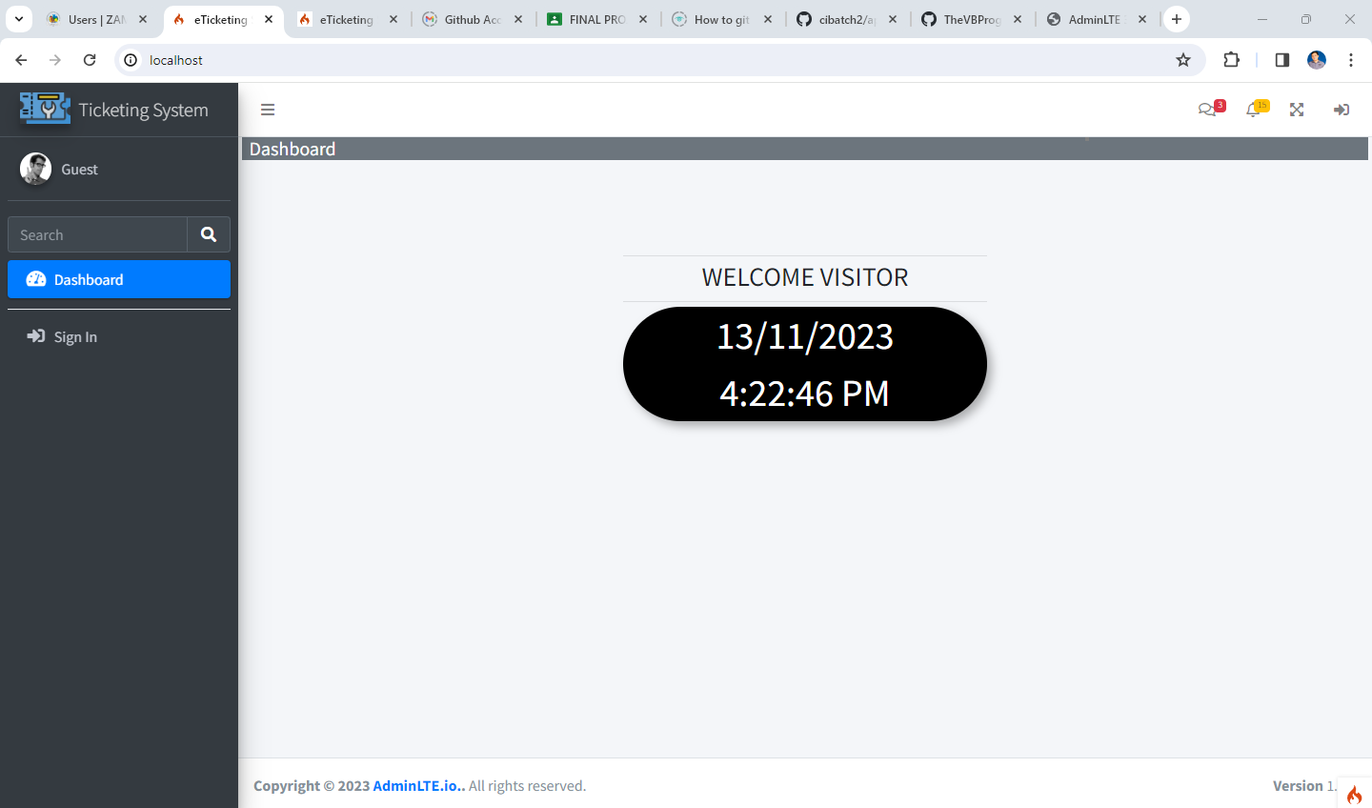

## Login Page:

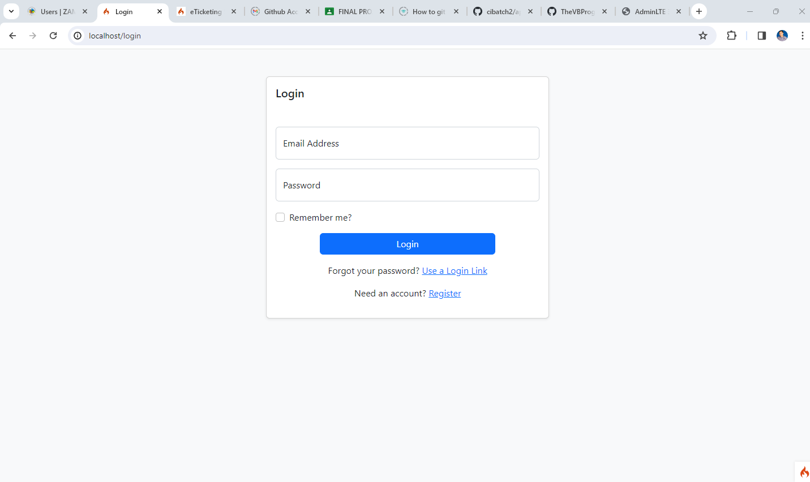

## Registration Page:

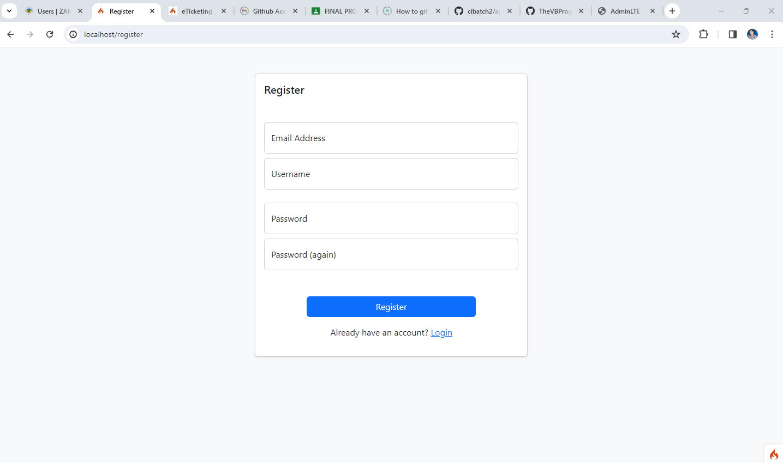

## Main Dashboard:

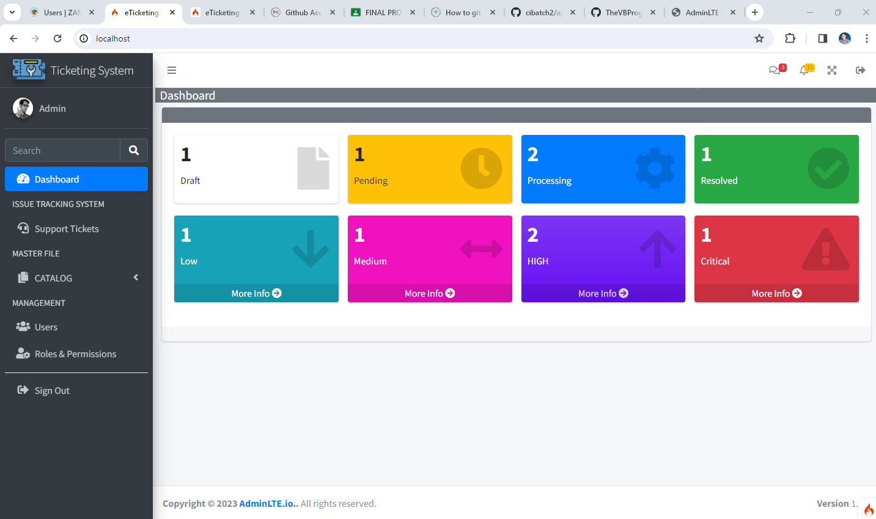

## Support Ticket Management Page:

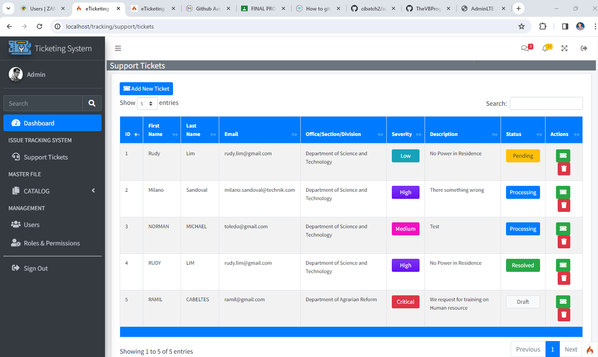

## Action Ticket Dialog Box:

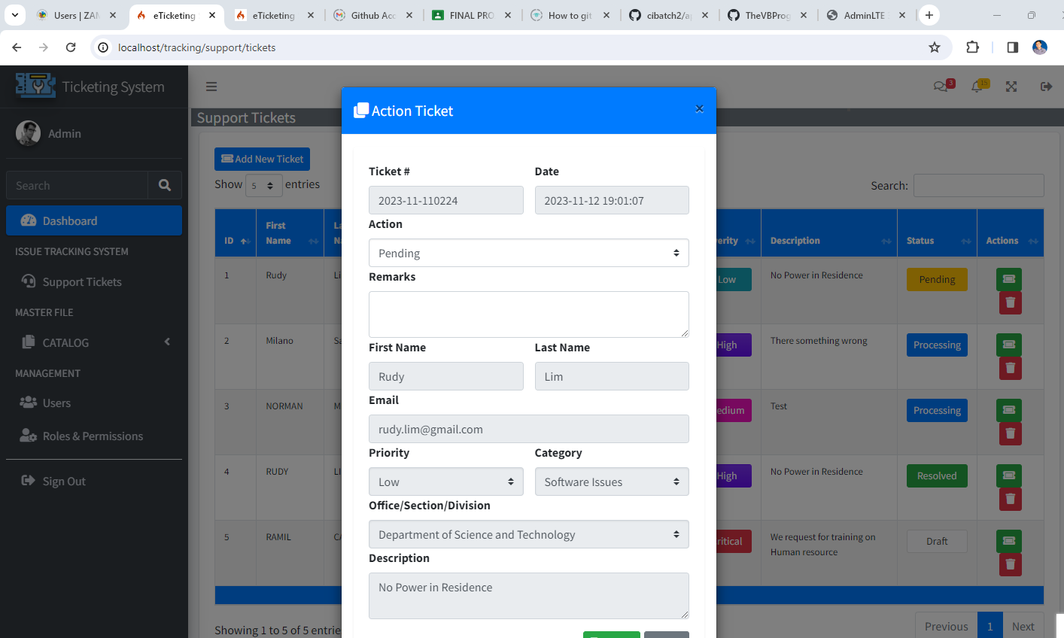

## Add New Ticket Dialog Box:

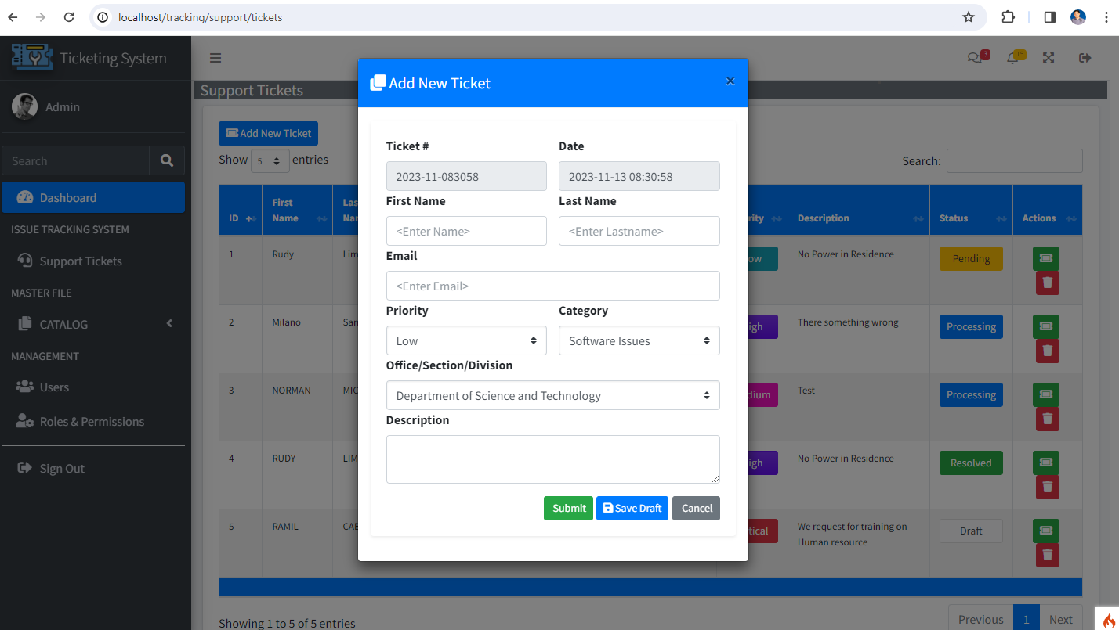

## Categories Page:

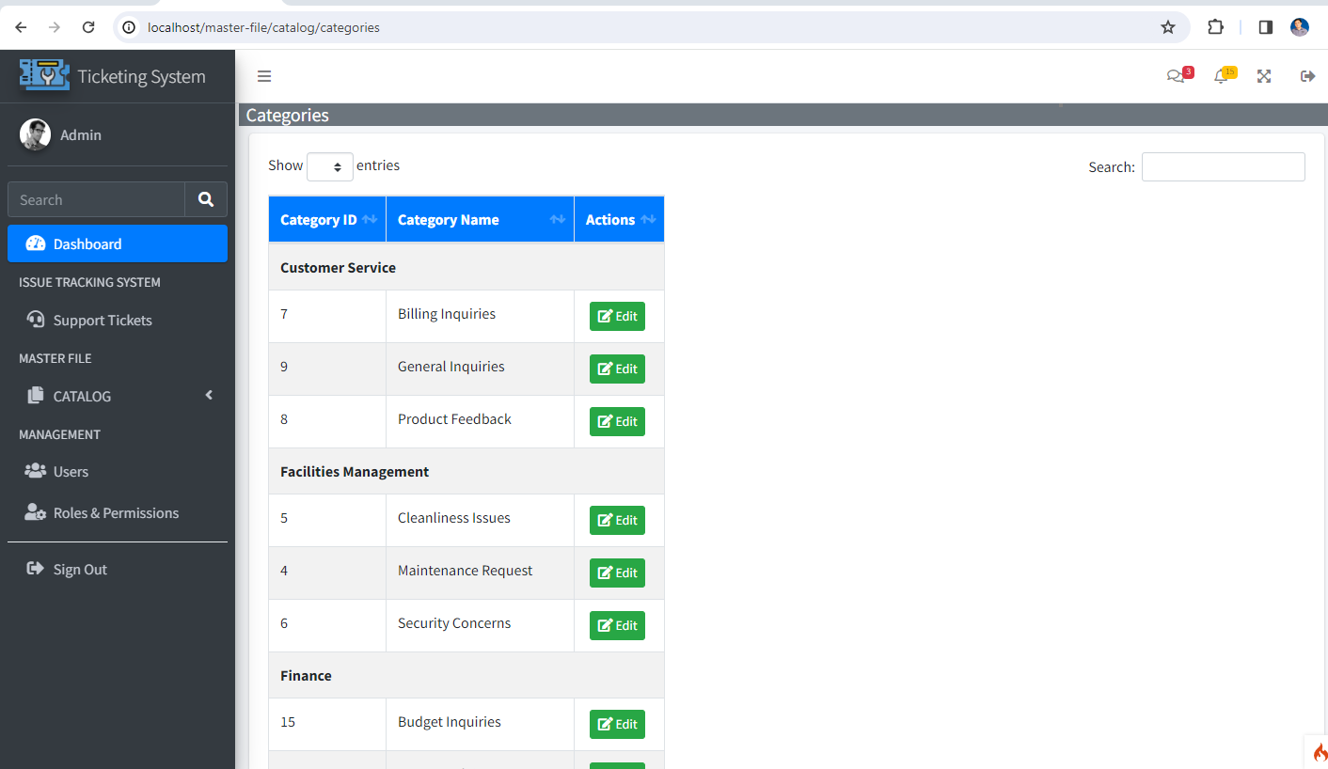

## Category Group page:

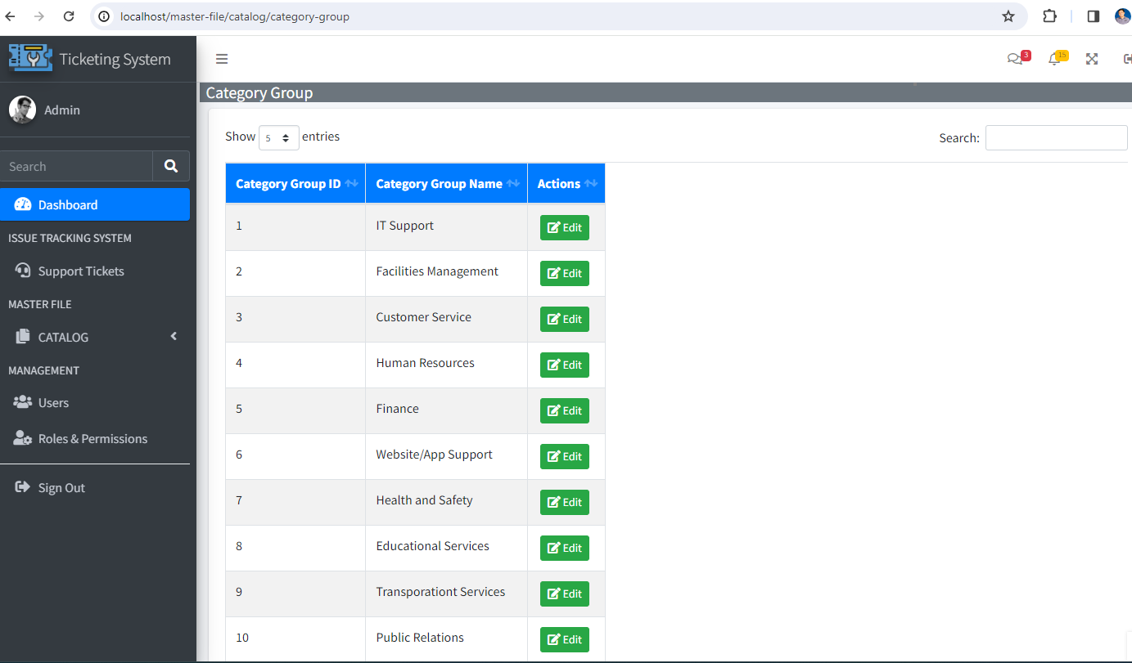

## Office Management Page:

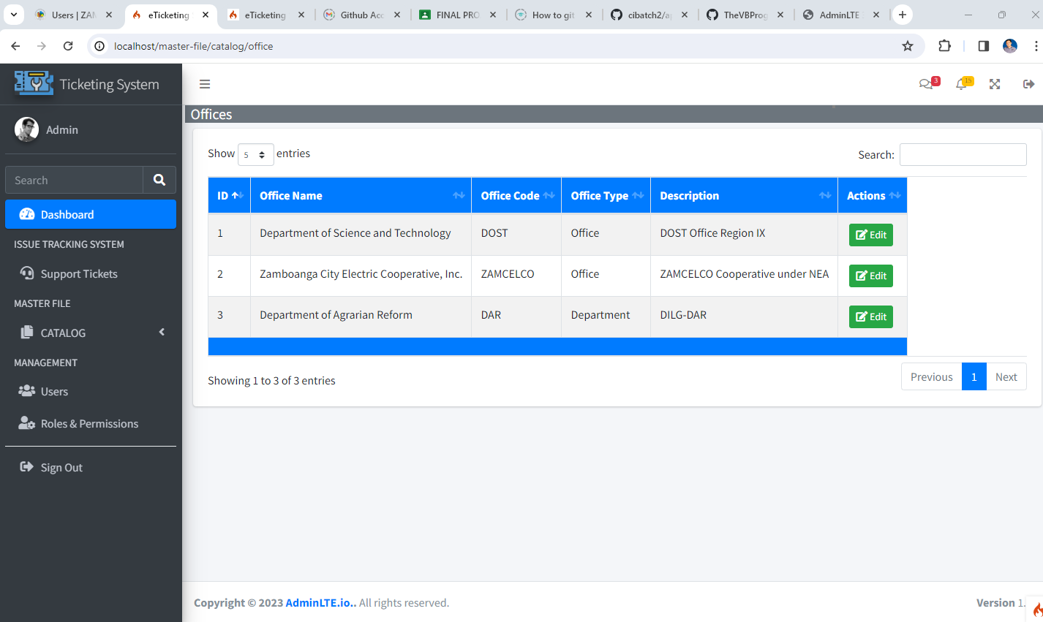

## User Management Page:

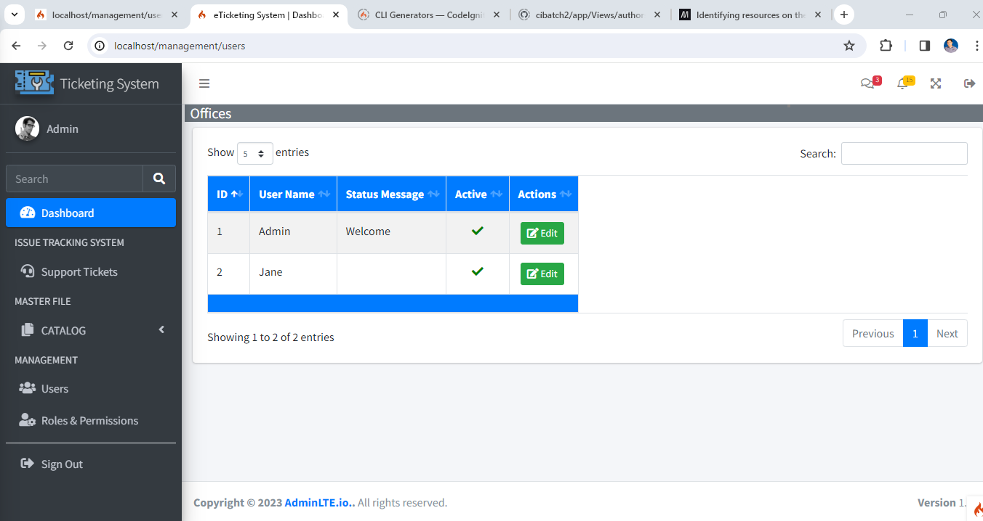

## Update User Dialog Box:

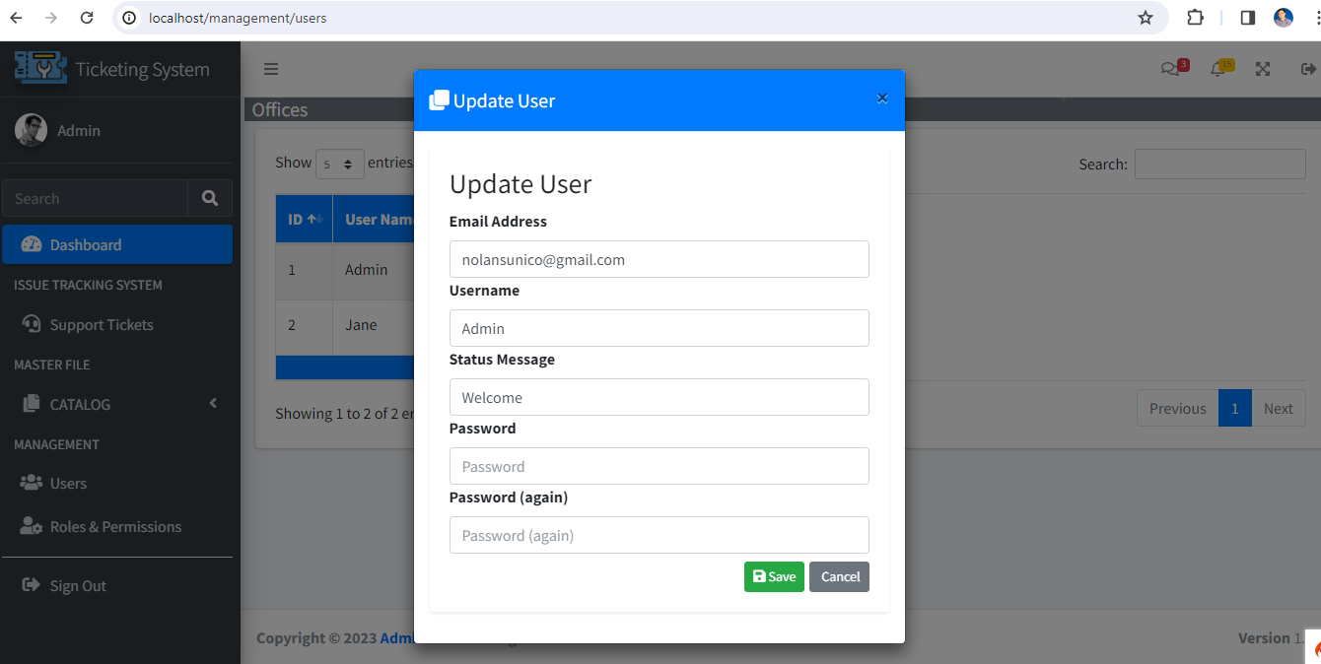

## Roles and Permissions Management Page:

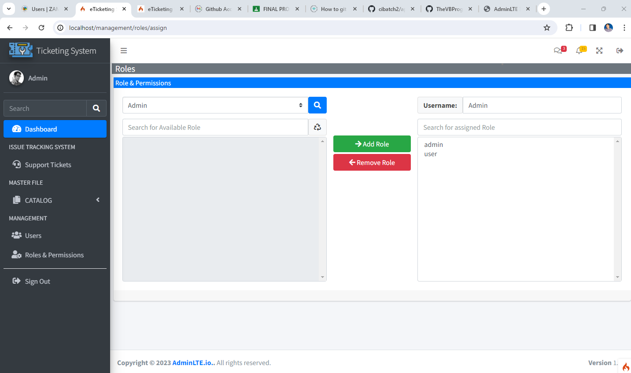

# IV SOURCE CODE

* Github Project Repository:
  + <https://github.com/TheVBProgrammer/eTicketing>

# V SUMMARY AND DISCUSSION

In the "Summary and Discussion" section, we undertake a comprehensive reflection on the development journey and outcomes of our eTicketing System project. This summary encapsulates our key achievements, the challenges we encountered, and the practical implications of our work, shedding light on how it fulfills its initial objectives and adds substantial value to its intended audience.

Throughout this summary, we acknowledge the successful aspects of the eTicketing System project, emphasizing how it aligns with its original goals and objectives. The system's relevance and utility are highlighted, showcasing its effectiveness in meeting the identified needs and challenges within the realm of a ticketing system developed using CodeIgniter 4.4.

Addressing the challenges faced during the development process, we recognize the complexities and hurdles that were navigated by the development team. This acknowledgment provides a transparent view of the project's journey, emphasizing the dedication and effort invested in overcoming obstacles.

Furthermore, the summary explores the practical implications of the eTicketing System, emphasizing its real-world applications and the benefits it brings to both administrators (with roles like "Admin") and users. The system's ability to streamline the ticket submission process, customize categories and priorities, and differentiate user roles stands out as a significant contribution.

The analysis extends to the project's impact, limitations, and potential future enhancements. We provide a balanced perspective on the broader significance of the eTicketing System, recognizing its strengths while also acknowledging areas for potential improvement. This insightful assessment positions the project within the context of web development and CodeIgniter, contributing to ongoing discussions and paving the way for future enhancements and innovations.

In conclusion, the "Summary and Discussion" section serves as a thoughtful conclusion to the eTicketing System project. It encapsulates our team's accomplishments, lessons learned, and the broader implications of our work within the dynamic landscape of web development and the CodeIgniter framework. This reflective analysis provides valuable insights for future projects and developments in the field.

The eTicketing System provides a comprehensive solution for managing support tickets with customized categories and category groups. The flexibility of the system allows for efficient handling of diverse support requests, enhancing communication and resolution processes. The modular architecture ensures easy customization and scalability, making it an ideal choice for organizations of various sizes.